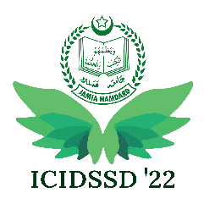
3rd International Conference on ICT for Digital, Smart, and Sustainable Development
March 24 – 25, 2022
Template for Special Session Request Form

Special Session Title

Special Session Abstract

Special Session chair(s): Name, Affiliation, Address, Mobile Number and e-mail (Not more than 2)

Expected Numbers of Papers to be submitted

Tentative list of Program committee members (Name, affiliation, country, and email address)

The special session proposals must be sent to icidssd22@jamiahamdard.ac.in. For further queries visit http://www.jamiahamdard.ac.in/icidssd/

